**LIBRARY MANAGEMENT SYSTEM**

A Mini Project Report Submitted

in Partial Fulfillment of the Requirements

for the Degree of

BACHELOR OF TECHNOLOGY

in

Electronics & Communication Engineering

by

MANSI GARG

(1900320310089)

Under the Supervision of

Mrs. Manidipa Roy



ABES ENGINEERING COLLEGE

GHAZIABAD, U.P.

2021-2022

**ACKNOWLEDGEMENT**

I, express my sincere thanks to my supervisor, Mrs. Manidipa Roy ECE Department, ABES Engineering College, Ghaziabad for guiding us right from the inception till successful completion of this mini project. I would also like to thank our HoD Prof. (Dr.) Sanjay Kumar Singh for his valuable guidance and cooperation during the conduction of this mini project.

Signature:

Name: Mansi Garg (1900320310089)

Date: 08/12/2021

**ABSTRACT**

***PYTHON***  : Python is a widely used general-purpose, high level programming language. It was created by Guido van Rossum in 1991 and further developed by the Python Software Foundation. It was designed with an emphasis on code readability, and its syntax allows programmers to express their concepts in fewer lines of code.

Python ranks among the most popular and fastest-growing languages in the world. Python is a powerful, flexible, and easy-to-use language. In addition, the community is very active there. It is used in many organizations as it supports multiple programming paradigms.

Python is a programming language that lets you work quickly and integrate systems more efficiently and helps in making projects easily as we have made **Library Management System**

* Library management systems are designed to manage the movement of books and maintain records of the members in a library. The software solution is designed based on the system requirements, the people involved, the content of the operation and the activity to be performed.
* It becomes necessary for colleges to keep a continuous check on the books issued and returned and even calculate fine. This task if carried out manually will be tedious and includes chances of mistakes. These errors are avoided by allowing the system to keep track of information such as issue date, last date to return the book and even fine information and thus there is no need to keep manual track of this information which thereby avoids chances of mistakes.  
  Thus this system reduces manual work to a great extent allows smooth flow of library activities by removing chances of errors in the details.

**CONTENTS**

1. **Chapter – 1:**

**INTRODUCTION**…………………………

**2. Chapter – 2:**

**PROGRAM CODE**………………………….

**3. Chapter – 3:**

**ACTUAL SCREENS**………………………

1. **CONCLUSION**……………………………………
2. **REFERENCES**…………………………………....

**INTRODUCTION**

* Library management systems are designed to manage the movement of books and maintain records of the members in a library. The software solution is designed based on the system requirements, the people involved, the content of the operation and the activity to be performed.
* It becomes necessary for colleges to keep a continuous check on the books issued and returned and even calculate fine. This task if carried out manually will be tedious and includes chances of mistakes. These errors are avoided by allowing the system to keep track of information such as issue date, last date to return the book and even fine information and thus there is no need to keep manual track of this information which thereby avoids chances of mistakes.  
  Thus this system reduces manual work to a great extent allows smooth flow of library activities by removing chances of errors in the details.
* This project of “LIBRARY MANAGEMENT” of gives us the complete information about the library. We can enter the record of new books and retrieve the details of books available in the library. We can issue the books to the students and maintain their records and can also check how many books are issued and stock available in the library. In this project we can maintain the late fine of students who returns the issued books after the due date. Throughout the project the focus has been on presenting information and comments in an easy and intelligible manner. The project is very useful for those who want to know about Library Management System.

**PROGRAM CODE**

**class Library:**

**def _init_(self, listofBooks):**

**self.books = listofBooks**

**def displayAvailableBooks(self):**

**print(f"\n{len(self.books)} AVAILABLE BOOKS ARE: ")**

**for book in self.books:**

**print(" ♦-- " + book)**

**print("\n")**

**def borrowBook(self, name, bookname):**

**if bookname not in self.books:**

**print(**

**f"{bookname} BOOK IS NOT AVAILABLE EITHER TAKEN BY SOMEONE ELSE, WAIT UNTIL HE RETURNED.\n")**

**else:**

**track.append({name: bookname})**

**print("BOOK ISSUED : THANK YOU KEEP IT WITH CARE AND RETURN ON TIME.\n")**

**self.books.remove(bookname)**

**def returnBook(self, bookname):**

**print("BOOK RETURNED : THANK YOU! \n")**

**self.books.append(bookname)**

**def donateBook(self, bookname):**

**print("BOOK DONATED : THANK YOU VERY MUCH, HAVE A GREAT DAY AHEAD.\n")**

**self.books.append(bookname)**

**class Student():**

**def requestBook(self):**

**print("So, you want to borrow book!")**

**self.book = input("Enter name of the book you want to borrow: ")**

**return self.book**

**def returnBook(self):**

**print("So, you want to return book!")**

**name = input("Enter your name: ")**

**self.book = input("Enter name of the book you want to return: ")**

**if {name: self.book} in track:**

**track.remove({name: self.book})**

**return self.book**

**def donateBook(self):**

**print("Okay! you want to doante book!")**

**self.book = input("Enter name of the book you want to donate: ")**

**return self.book**

**if __name__ == "_main_":**

**Delhilibrary = Library(**

**["vistas", "invention", "rich&poor", "indian", "macroeconomics", "microeconomics"])**

**student = Student()**

**track = []**

**print("\t\t\t\t\t\t\t♦♦♦♦♦♦♦ WELCOME TO THE DELHI LIBRARY ♦♦♦♦♦♦♦\n")**

**print("""CHOOSE WHAT YOU WANT TO DO:-\n1. Listing all books\n2. Borrow books\n3. Return books\n4. Donate books\n5. Track books\n6. exit the library\n""")**

**while (True):**

**# print(track)**

**try:**

**usr_response = int(input("Enter your choice: "))**

**if usr_response == 1: # listing**

**Delhilibrary.displayAvailableBooks()**

**elif usr_response == 2: # borrow**

**Delhilibrary.borrowBook(**

**input("Enter your name: "), student.requestBook())**

**elif usr_response == 3: # return**

**Delhilibrary.returnBook(student.returnBook())**

**elif usr_response == 4: # donate**

**Delhilibrary.donateBook(student.donateBook())**

**elif usr_response == 5: # track**

**for i in track:**

**for key, value in i.items():**

**holder = key**

**book = value**

**print(f"{book} book is taken/issued by {holder}.")**

**print("\n")**

**if len(track) == 0:**

**print("NO BOOKS ARE ISSUED!. \n")**

**elif usr_response == 6: #exit**

**print("THANK YOU ! \n")**

**exit()**

**else:**

**print("INVAILD INPUT! \n")**

**except Exception as e: #catch errors**

**print(f"{e}---> INVALID INPUT! \n")**

**ACTUAL SCREENS**

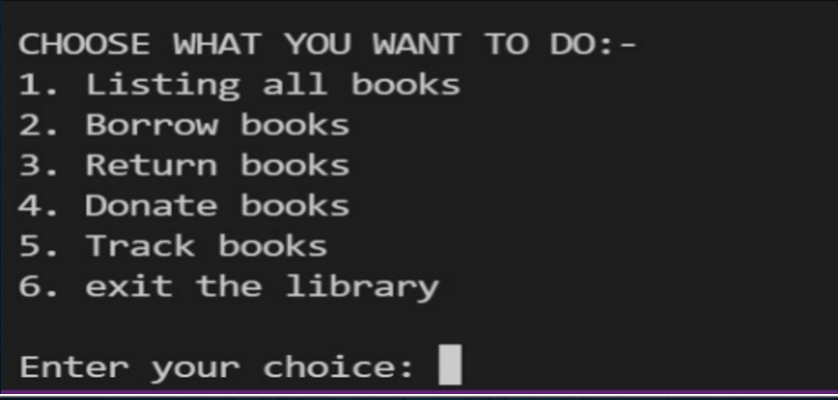

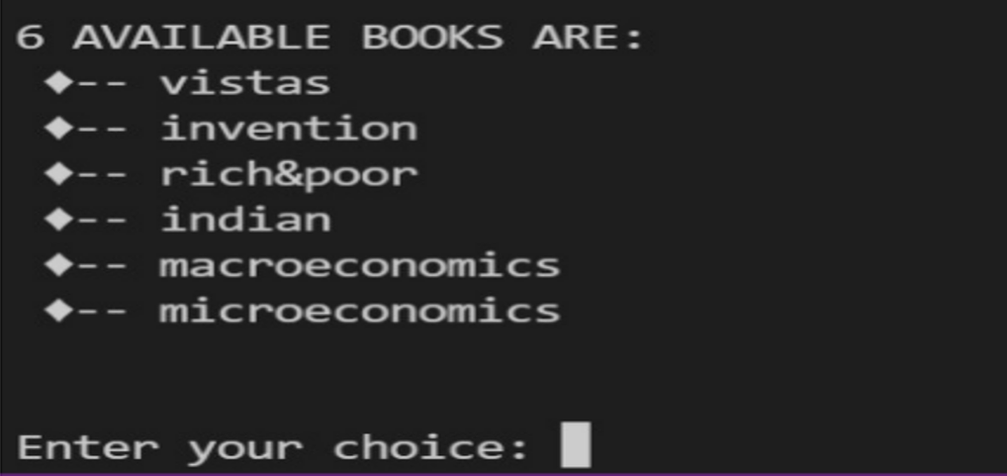

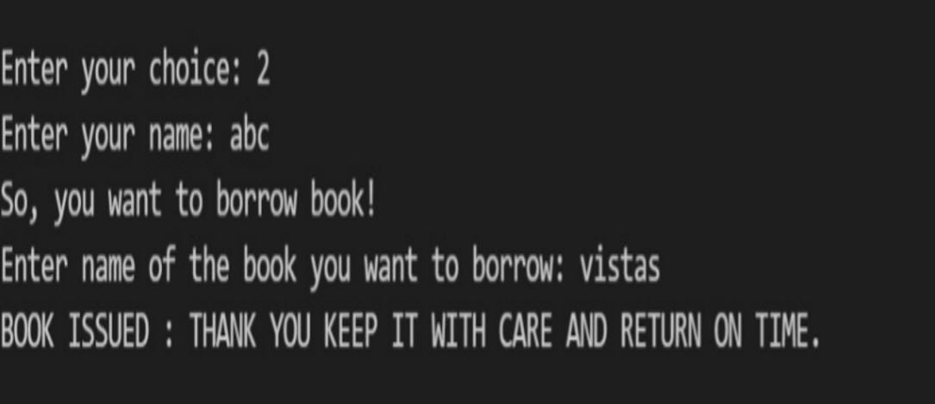

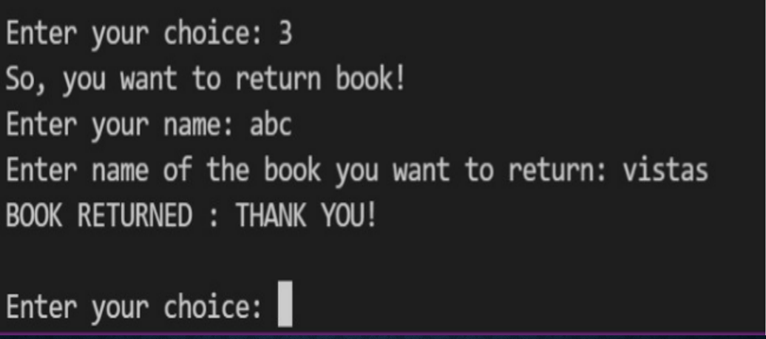

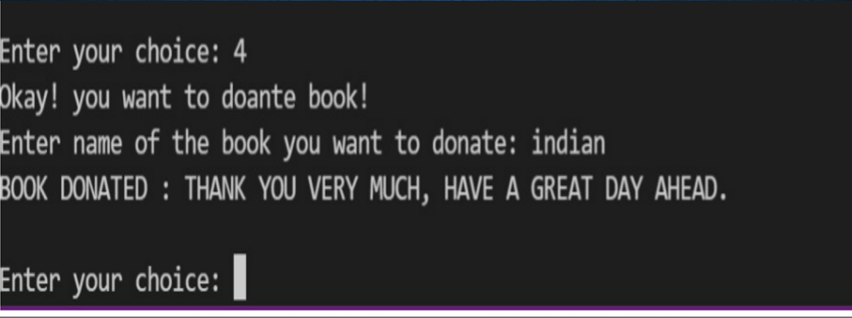

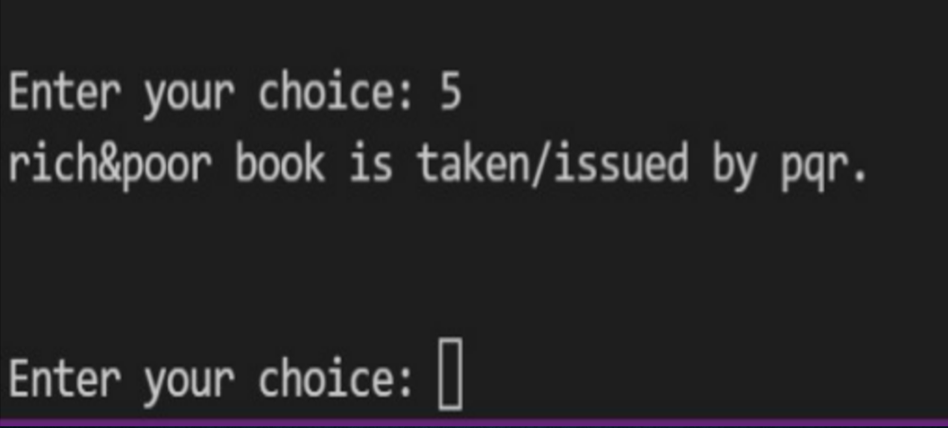

**CONCLUSION**

After we have completed the project we are sure the problems in the existing system would overcome. The “LIBRARY MANAGEMENT SYSTEM” process made computerized to reduce human errors and to increase the efficiency. The main focus of this project is to lessen human efforts. The maintenance of the records is made efficient, as all the records are stored in the ACCESS database, through which data can be retrieved easily

The Books and Students are given a particular unique id no. So that they can be accessed correctly and without errors. Our main aim of the project is to get the correct information about a particular student and books available in the library.